Chapter 16, Problem 99.

It is desired to realize the transfer function

using the circuit in Fig. 16.108. Choose R = 1 kΩ and find L and C.

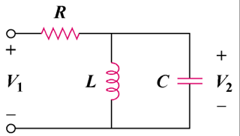

Figure 16.108
For Prob. 16.99.

